Prim's Algorithm
1. Problem Statement
We are given a connected graph with a set of vertices and a set of edges. Each edge has a weight attached to it. The task is to find a Minimum Spanning Tree of this graph. A Minimum Spanning Tree is a smaller connected graph that touches every vertex once, has no cycle in it, and has the least possible total edge weight among all such trees.
Prim's algorithm is another method used to solve this problem. Unlike Kruskal's algorithm, which picks edges from the whole graph, Prim's algorithm grows the spanning tree from a single starting vertex, adding the cheapest edge that connects a new vertex to the tree at every step.
2. Approach Used
Step 1: Start with one vertex and mark it as part of the spanning tree.
Step 2: Keep a key value for every vertex, which stores the smallest weight of an edge that connects that vertex to the tree so far. Set this value to a very large number for all vertices except the starting one.
Step 3: Among the vertices not yet in the tree, pick the one with the smallest key value.
Step 4: Add this vertex to the tree, and update the key values of its neighbours if a cheaper connecting edge is found.
Step 5: Repeat step 3 and step 4 until every vertex has been added to the tree.
Step 6: The edges recorded while updating the key values form the Minimum Spanning Tree.
3. C Program
The following program implements Prim's algorithm using an adjacency matrix. It picks the minimum key vertex at every step and updates the key values of its neighbours. The program does not use any comments.
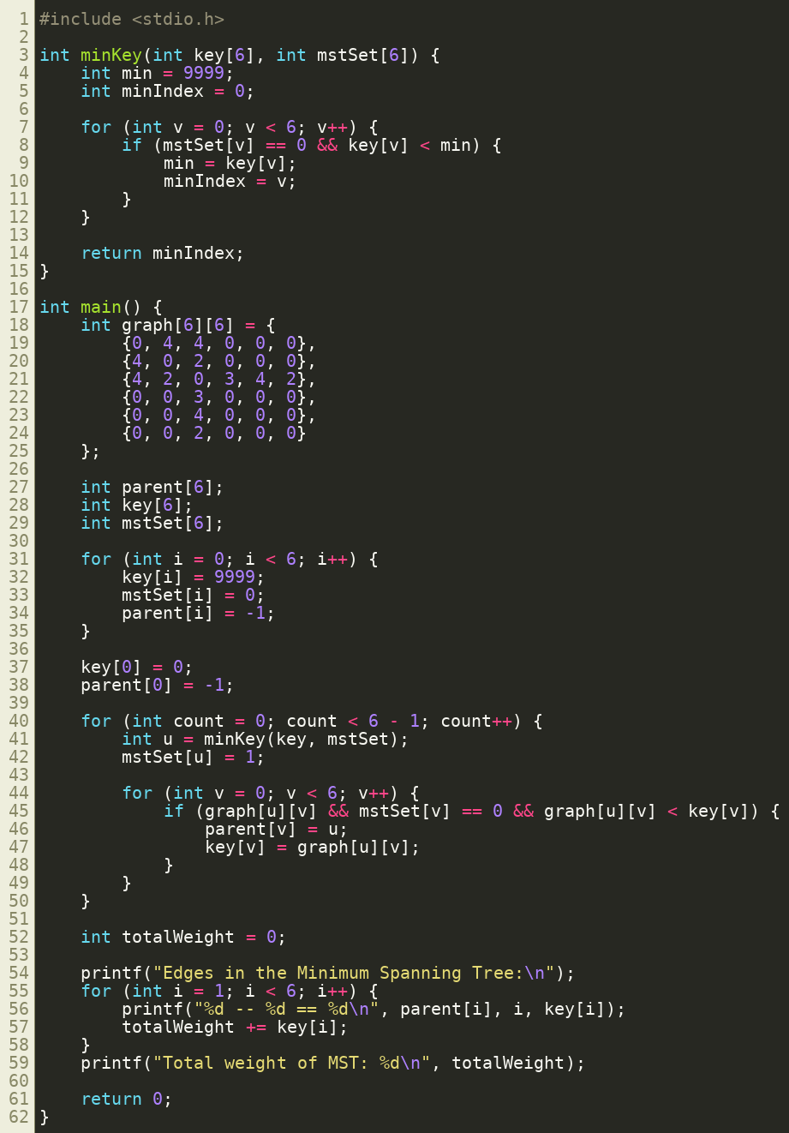
4. Output
The program was compiled and run on the same graph with six vertices and six edges that was used for Kruskal's algorithm. The output below shows the edges selected for the Minimum Spanning Tree along with their weights, and the total weight of the tree, which matches the result obtained from Kruskal's algorithm.
